January 25, 2016
For immediate release:

The UH School of Theatre & Dance, The UH Honors College Center for Creative Work, and The Blaffer Museum present the return of The Catastrophic Theatre's production of
The Hunchback Variations
by Mickle Maher
It’s back! Because you demanded it! Four nights only!
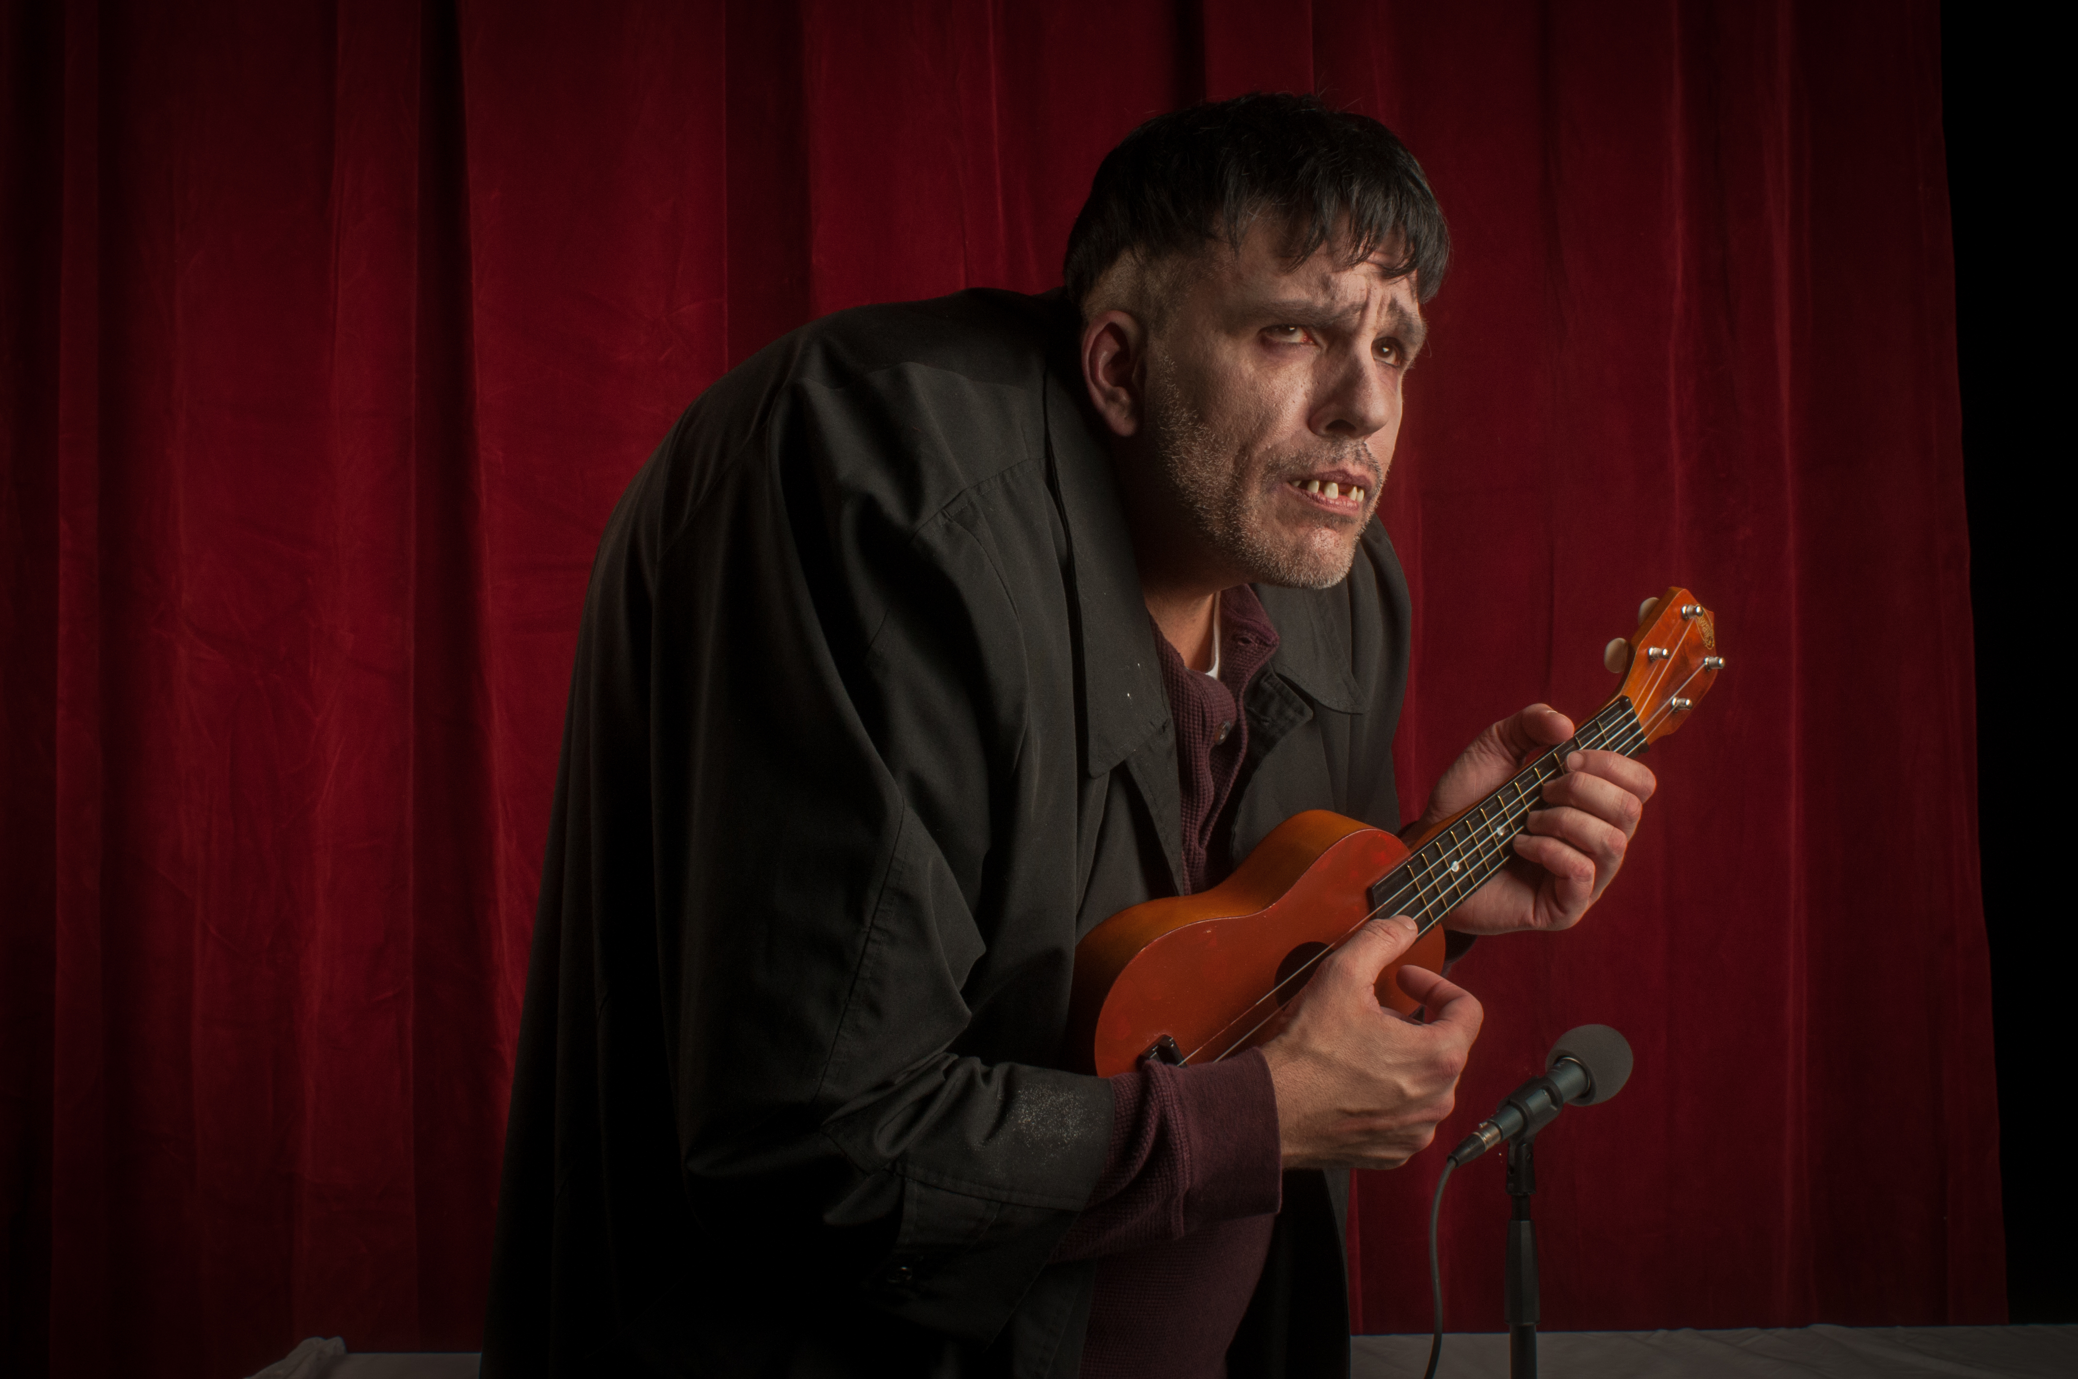
February 18, 19, 26, & 27, 2016
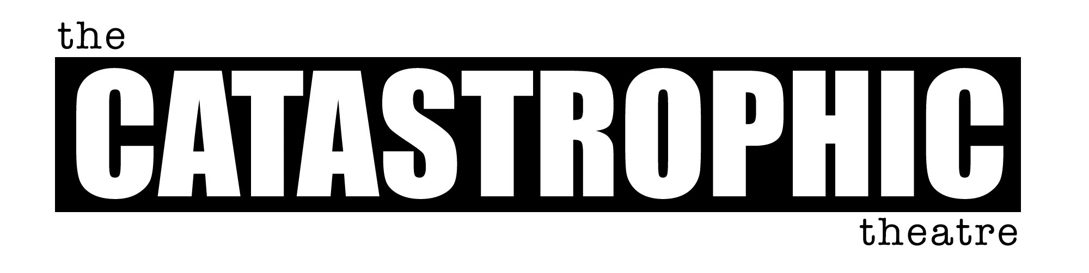
Fridays & Saturdays at 8pm
3400 Main, Suite 285
Houston, Texas 77002
Ph. 713-522-2723

Jason Nodler
Artistic Director
Paul Brockman
Managing Director
Tamarie Cooper
Associate Director

Board of Directors
Caroline Starry LeBlanc
President

Vice President
Mark Yzaguirre
Treasurer
Anika Jackson
Secretary

Mark Johnson
William Kennerly
Lise Liddell
Paul Menzel
Lauren Reeder
Tim Thomson

Advisory Board
Bill Arning
Frank Black
Gregory Boyd
Susan Choi
Lisa D'Amour
Shaila Dewan
Dan Dubrowski
Karen Farber
Daniel Johnston
Rich Levy
Mickle Maher
Kenn McLaughlin
Daryl Morey
Jim Parsons
Emily Todd
Rebecca Udden
Dominic Walsh
Michael Zilkha
at the UH Engineering Lecture Hall
http://www.uh.edu/maps/buildings/?short_name=D2
All tickets Pay-What-You-Can
“Thanks to playwright Mickle Maher’s terrifically funny for even non-geniuses script, whip cracking tight direction by Greg Dean and two outstandingly funny yet thought-provoking performances, this is a theatrical experience worthy of wide attention.” - Jessica Goldman, Applause-Meter

About the Play
In The Hunchback Variations, noted composer Ludwig Van Beethoven and noted hunchback Quasimodo team up to chair a panel on sound design. More specifically they are explaining their fruitless efforts to create the impossible cue: that baffling sound effect described at the end of Anton Chekhov’s The Cherry Orchard. The panel follows the pair’s frustrated efforts, complicated by the fact that they are both quite deaf.
Thematically, the play explores the creative impulse and the question of artistic endeavor. Is it a noble thing to continue to try in the face of inevitable failure or is it better to simply remain silent?
Maher has become a Houston favorite a result of Catastrophic productions of his plays The Hunchback Variations, The Strangerer, Spirits to Enforce, There Is A Happiness That Morning Is, and the world premiere of The Pine.
Catastrophic first presented The Hunchback Variations to wide acclaim in its 2015 season. The production features Greg Dean as Quasimodo and Jeff Miller as Beethoven and is directed by Greg Dean. Scenery and properties are by Greg Dean, with lighting by Dustin Tannahill, costumes by Macy Lynn, and sound by John Peeples. UH student Chandler Harvey stage manages.
—
About the Co-Production
“I can speak for my Colleagues John Harvey, Director of the UH Honors College Center for Creative Work and Jim Rosengren, Deputy Director of the Blaffer Museum, when I say that we are all thrilled to be co-hosting The Catastrophic Theatre’s remount of Mickle Maher’s The Hunchback Variations. I had seen Catastrophic's original production and loved it. It's such a brilliant, quirky concept for a play, and the production itself was both hysterically funny and very moving. And at its heart, it's a play about artistic collaboration—how thrilling and infuriating and downright weird it can be for artists to work together, especially on a very challenging project. Plus, John, Jim, and I all greatly admire The Catastrophic Theatre. They enjoy a national reputation as a leading avant-garde theatre company for good reason.

“On the UH side of things, we are very happy to be able to host such an exciting project right on campus, where it can be attended by lots of UH students. Catastrophic’s policy of all tickets being pay-what-you-can means that any student who wants to attend the show can do so. And it's actually a brilliant idea to stage The Hunchback Variations in a real university lecture hall since the play is set in a scholarly environment: an academic conference on sound design. Catastrophic’s artistic director Jason Nodler and I were able to look at various lecture halls around campus until we came to one that felt just perfect. Ultimately, I'm very excited about how all four organizations have partnered to present this fascinating show. It's a terrific thing to be able to bring some of the best theatre in the city of Houston right to the UH campus.” - Dr. Rob Shimko, UH Theatre Professor
—
About the Playwright
Mickle Maher is a cofounder of Theatre Oobleck, and has been a playwright/adaptor/translator for 20 years. He has authored eight plays for Oobleck, including The Strangerer (funded by a grant from Creative Capital), Spirits to Enforce, and The Hunchback Variations. Other plays include Cyrano (translator) and The Cabinet for Redmoon Theater, and Lady Madeline for Steppenwolf Theatre Company. Maher’s works have been produced throughout the country and in Europe.
In 2008, The Catastrophic Theatre produced Maher's The Strangerer and Spirits to Enforce to both popular and critical acclaim. The Houston Chronicle called Maher "one of the most original voices in American theatre today."
---

The Catastrophic Theatre
3400 Main, Suite 285
Houston, TX 77002
713-522-2723
http://catastrophictheatre.com

Contact:
Paul Brockman, Managing Director
paul.brockman@catastrophictheatre.com
713-522-2723x3

