October 13, 2016
For immediate release:
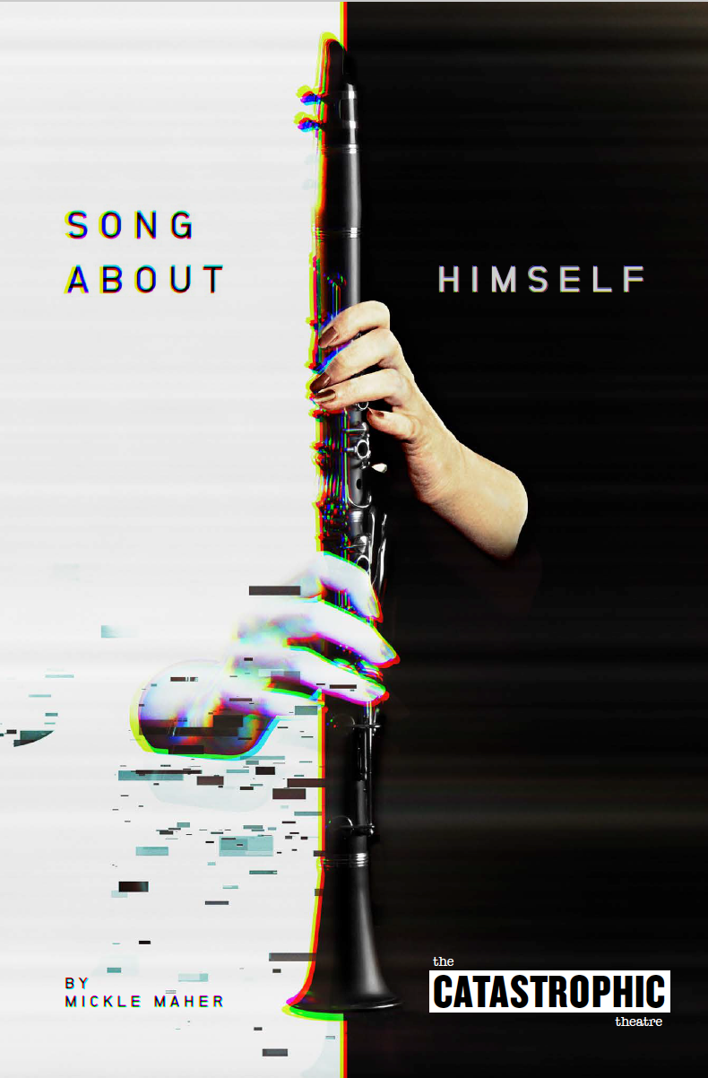
The Catastrophic Theatre
presents
Song About Himself
by Mickle Maher
Friday, November 11th -
Saturday, December 3, 2016
Thursdays, Fridays & Saturdays at 8 pm at The MATCH, 3400 Main Street

Directed by Jason Nodler
Starring Tamarie Cooper, Jovan Jackson, and Noel Bowers

Ticket Price:
You Tell Us
We Suggest $35
More If You Have It
Less If You Don't

In a dystopian future, a corrupted and crumbling version of the Internet, now called “the Weed,” allows human beings to communicate in only the most banal and fragmentary ways. A woman named Carol, perhaps the only person left able to string together a few coherent sentences in a world devolving into gibberish, joins YouSpake, a rogue social media site maintained by an enigmatic host/hostess. The secrets Carol uncovers will either reconnect her to humanity or destroy her heart. A strangely poetic and ultimately moving exploration of how we do and don’t communicate in the internet age, Song About Himself features the evocative use of minimalist staging that calls to mind a computer continually crashing and rebooting in a void, as well as a highly original form of verse derived from a corruption of Walt Whitman’s Leaves of Grass. Anyone curious about what form the Theatre of the Absurd might take in the present moment will find a unique and provocative answer in Song About Himself.

“Ultimately Maher is digging his finger around in that gaping hole of what it means to connect with another person—the wistful, persistent desire for it, and the technology that we've come to rely on to make so much of it possible.”
—Nina Metz, Chicago Tribune

Song About Himself will be the sixth play by the Chicago-based Mickle Maher staged by The Catastrophic Theatre, and it cements his position as Catastrophic’s most frequently produced playwright. The Chicago Reader hailed Maher’s play as “nearly perfect” and notes that of his “many artful, resonant plays, this one has the potential to eclipse them all.” Other Maher plays Catastrophic has produced are The Hunchback Variations, There Is A Happiness That Morning Is, Spirits to Enforce, The Strangerer, and the world premiere of The Pine, commissioned by a MAP Fund grant. Through those productions he has become a favorite to Houston audiences and the last two of his plays that we produced (Hunchback Variations, There Is A Happiness…) were so popular we had to bring each of them back for a second run.

Abby Koenig, writing for The Houston Press said of There Is A Happiness That Morning Is, “This is what theatre is supposed to be.” Everett Evans, writing of the same play for The Houston Chronicle wrote, “I can scarcely contain my enthusiasm for Catastrophic Theatre’s ideally realized presentation of Mickle Maher’s delightfully original There Is a Happiness That Morning Is, so I’m not even going to try… If you prize imagination, intelligence and genuine passion, you’ll be on cloud nine through all 90 minutes of this utterly unpredictable experience.” And D.L. Groover (Houston Press) called The Hunchback Variations "a thinking man's vaudeville." In fact each of the five Maher plays Catastrophic has previously produced has received superlative reviews and has been wildly popular with audiences.

Song About Himself will be Catastrophic’s third play in its new home at The MATCH after sold-out runs of Tamarie for President (Greatest Hits, Vol. II) and Sam Shepard’s Buried Child.

As with every Catastrophic Theatre production all tickets are available on a sliding scale according to what each audience member can afford. As it has been for years now, everyone is welcome regardless of ability to pay and no one will be turned away for lack of funds.

—————————————

About the Playwright
Mickle Maher is a cofounder of Theatre Oobleck, and has been a playwright, adaptor, and translator for 20 years. He has authored eight plays for Oobleck, including The Strangerer (funded by a grant from Creative Capital), Spirits to Enforce, and The Hunchback Variations. Other plays include Cyrano (translator) and The Cabinet for Redmoon Theater, and Lady Madeline for Steppenwolf Theatre Company. Maher’s works have been produced throughout the country and in Europe. Prior Catastrophic Theatre productions of Maher’s work include The Strangerer and Spirits to Enforce in 2008, There Is a Happiness That Morning Is in 2012 and 2013, the World Premiere of The Pine in 2013 and The Hunchback Variations in 2015 and 2016. The Houston Chronicle called Maher "one of the most original voices in American theatre today."

Contact:
For more information about the production, visit catastrophictheatre.com or contact Paul Brockman at 713-522-2723 or paul.brockman@catastrophictheatre.com

For tickets and venue information, visit matchouston.org or call The MATCH’s box office at 713-521-4533

Tickets to all performances are: You Tell Us • We Suggest $35 • More If You Have It • Less If You Don't

