March 6, 2017
For immediate release:
The Catastrophic Theatre in association with the Barthelme Estate, University of Houston Libraries, Brazos Bookstore, Inprint, and University of Houston Cynthia Woods Mitchell Center for the Arts present
Snow White
by Donald Barthelme
April 7th - May 6th, 2017
Directed by Greg Dean

CounterCurrent17 performances: Thursday 4/20–Saturday 4/22

CounterCurrent17 Online Reservations Open 03/23/17!

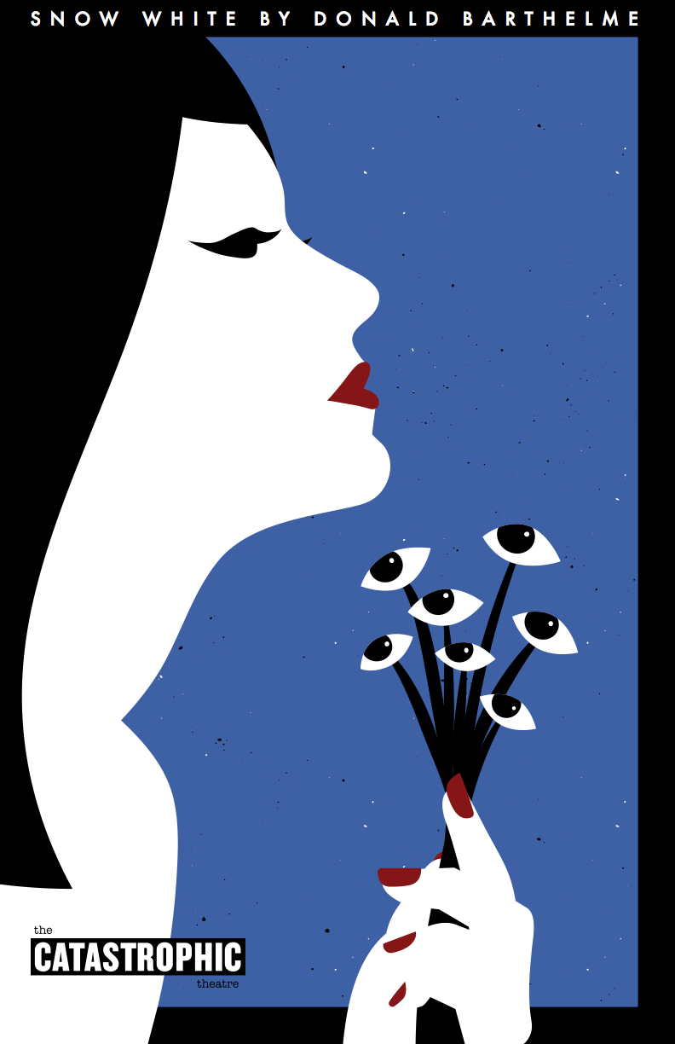
All performances presented @
The MATCH, 3400 Main Street
Thursday, Friday and Saturday @ 8 pm

Starring
Coralee Young as Snow White
with
Noel Bowers, Greg Cote, Greg Dean, John Dunn, Luis Galindo, Bobby Haworth, Xzavien Hollins, Courtney Lomelo,
Jeff Miller, Joel Orr, Charlie Scott and Abe Zapata

This world premiere production of Snow White is a theatrical adaptation of the groundbreaking, experimental novel by the postmodern novelist and poet Donald Barthelme.

Snow White is tired of being “just a horsewife” to Bill, Dan, Edward, Hubert, Henry, Clem and Kevin, who, in her estimation, “only add up to the equivalent of about two real men.” While the seven men toil in commercial real estate and manufacture exotic high-end baby foods, she whiles away her days reading Mao Tse-tung, drinking vodka with orange juice, and impatiently waiting for the prince promised to her by history.
This world premiere production of Snow White is a theatrical adaptation of the groundbreaking, experimental novel by the iconic, postmodern novelist, poet, and early faculty member of the University of Houston Creative Writing Program, the late Donald Barthelme. He began adapting Snow White for the stage in 1974, and a reading of his script was presented in 1976. The project was abandoned after that, but a version of the play was published in 1992, at the end of The Teachings of Don. B. In 1996, the Alley Theatre presented a private staged reading of the play. Working from Barthelme's original manuscript, notes and revisions, as well as the novel itself, Catastrophic Theatre will finally present the world premiere of Donald Barthelme’s Snow White to the public.
Snow White is produced in association with the Barthelme Estate, Brazos Bookstore, Inprint, University of Houston Cynthia Woods Mitchell Center for the Arts, CounterCurrent17 and features cast and crew from the UH School of Theatre and Dance.

As with every Catastrophic Theatre production all tickets are available on a sliding scale according to what each audience member can afford. As it has been for years now, everyone is welcome regardless of ability to pay and no one will be turned away for lack of funds.

About Donald Barthelme
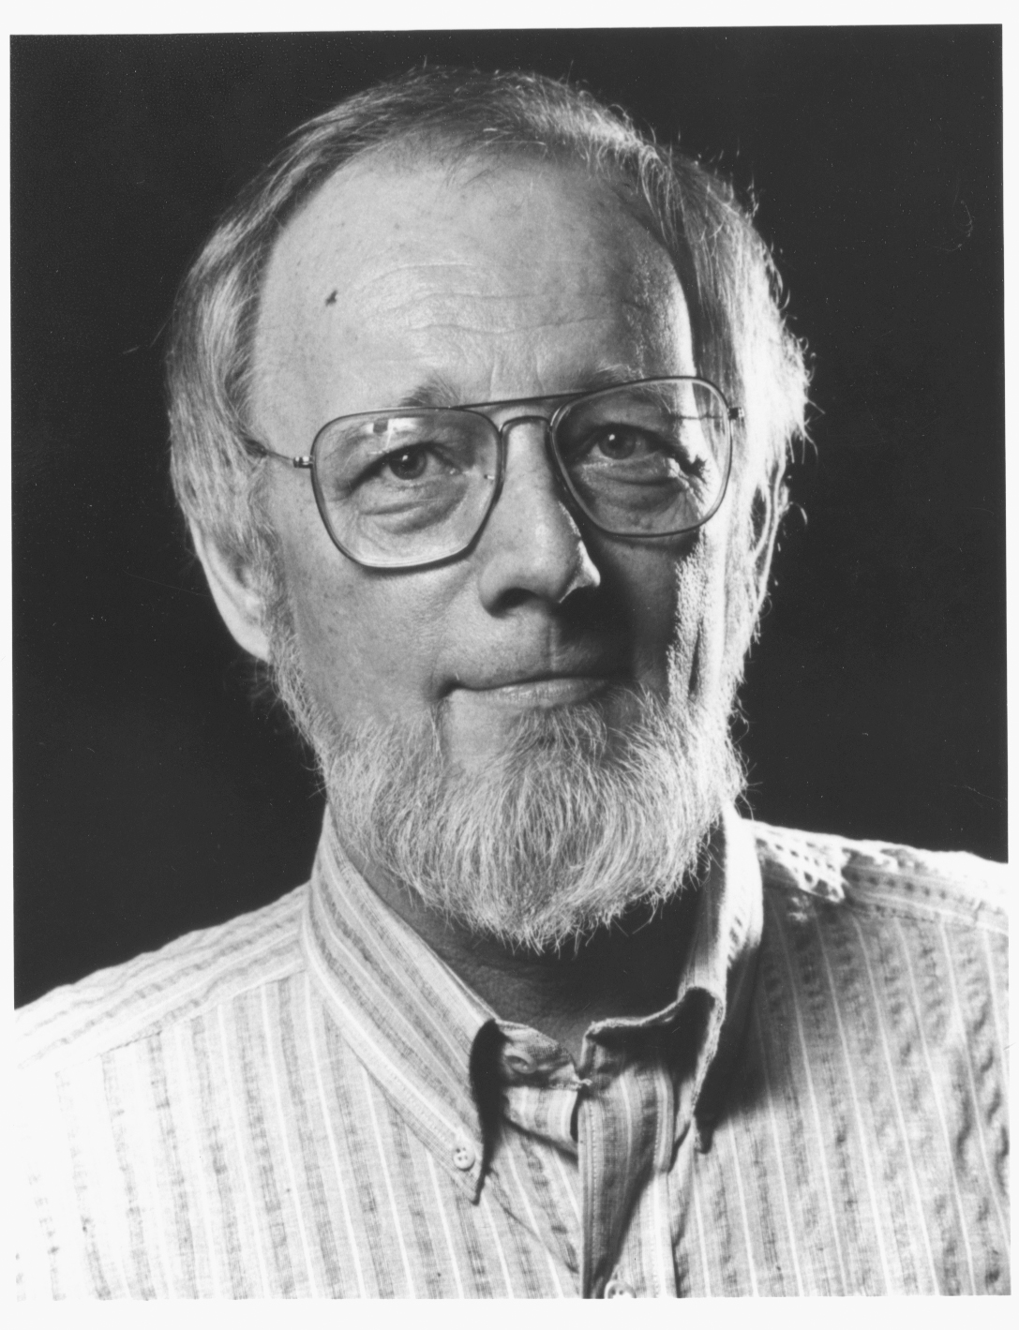
Donald Barthelme (1931–1989) published twelve books, including two novels and a prize-winning children's book. He was a regular contributor to The New Yorker and divided his time between New York and Houston, where he taught creative writing at the University of Houston. Writing in Life magazine, Webster Schott called Barthelme "the most perversely gifted writer in the United States. . . . Snow White has everything, including William Burroughs cut ups, words posing as paintings, ribald social commentary, crazy esthetic experiments and comedy that smashes.”
Barthelme was vitally important to the development of the Houston literary community. As one of the first faculty members at the University of Houston Creative Writing Program (UH CWP), Barthelme – a Houston native returning after many years and great artistic and critical success in New York – helped to attract some of the nation’s top emerging and established writers to Houston. Renowned as a teacher and mentor, he was also instrumental in launching the Houston Reading Series (which became the Inprint Margarett Root Brown Reading Series).
________________________________________________________________________________________________________________

About CounterCurrent
CounterCurrent is a free festival of performance, installation, and ideas. Presented by the Cynthia Woods Mitchell Center for the Arts, CounterCurrent includes audio and visual installations, live performances, talks, and participatory events by artists from around the world. From large-scale spectacle to intimate interaction, CounterCurrent projects represent the range of ways we view each other and the city around us. The Cynthia Woods Mitchell Center for the Arts is part of the University of Houston Kathrine G. McGovern College of the Arts.
About Brazos Bookstore
In 1974, Karl Kilian opened Brazos Bookstore to encourage the growth and development of the emerging Houston literary scene with a clear focus on personalized service, community engagement and passionate curation. Larry McMurtry, Edward Albee, and Donald Barthelme were all regular customers during their times in Houston. As a hub for the most creative, intelligent and engaged readers in Houston, Brazos offers programs and curates its shelves to inspire and expand the horizons of curious readers. They aim to connect all readers with the best contemporary and classic literature, non-fiction, art and architecture monographs, and books for children. Brazos Bookstore supports writers and readers through long partnerships with Inprint!, the University of Houston Creative Writing Program, the Academy of American Poets, and the Annual Poet and Writer’s Ball. Brazos Bookstore continues to be locally owned by a group of twenty-seven Houstonians who came together and purchased the bookstore when Kilian announced his retirement in 2006.

About Inprint
Inprint is Houston's premier literary arts nonprofit organization. Their programs support and engage readers and writers of fiction, poetry, and creative nonfiction. Inprint serves as a vital wellspring of literary life, both locally and nationally. Thanks in large part to Inprint’s activities and support, Houston is a vibrant community of creative writers and readers, rich with workshops, readings, forums, and other kinds of literary activity. Writers from all backgrounds and parts of the world delight in coming to Houston to read, teach, and study creative writing; and thousands of Houstonians, recognizing the value and impact of the written word, join in Inprint programs to write, read, and support the literary arts. The community is enriched by some of the nation’s top emerging writers, who study at the University of Houston Creative Writing Program and teach at Inprint and in community centers, schools, universities, and other places throughout the Houston area.

About Cynthia Woods Mitchell Center for the Arts
The Cynthia Woods Mitchell Center for the Arts is dedicated to interdisciplinary collaboration across the performing, visual, and literary arts. Based at the University of Houston, the Mitchell Center commissions and produces new works, presents public performances and exhibitions, offers curriculum and scholarships, and hosts residencies with renowned visiting artists from throughout the world. The Center is home to the Mitchell Artist Lecture, an annual event featuring a pioneer in contemporary art-making, as well as CounterCurrent, an annual spring festival of new performance. The Mitchell Center forms an alliance among five departments at UH: the School of Art, Moores School of Music, School of Theatre & Dance, Creative Writing Program, and Blaffer Art Museum.

Snow White by Donald Barthelme. Copyright by Donald Barthelme, used with permission of The Wylie Agency LLC.

Contact:
For more information about the production, visit catastrophictheatre.com or contact us at 713-522-2723 or info@catastrophictheatre.com

For tickets and venue information, visit matchouston.org or call The MATCH’s box office at 713-521-4533
Tickets to all performances are: Pay-What-You-Can • We Suggest $35 • More If You Have It • Less If You Don't

